CST 352 – Lecture 7 Security
Wilsonville, Spring 2022

Ch 8, Authentication/authorization, models

Three critical security concepts for operating systems:
- Confidentiality – protect data from unauthorized access
- Integrity – keep data and system from being modified/deleted
- Availability – system is up and useable when users want it

Complexity:
- Programs access files, but we want to specify user permissions, not program permissions
- Files store information at rest, but info travels around the system too
- Many ways for operating systems and applications to become infected

There are many threats of gaining access and exploiting that access…

Example of Username/Password:
How do we validate password for a given username?
- Password file
- Hashed password
- Hashed password + salt
- Password complexity rules
But what about… Ctrl-Alt-Del fake password screens?

Example of Malware:
- Trojan Horse – run apparently for one purpose, but does something else, for example downloaded by phishing email
- Worm – exploits a weakness in the OS to gain access (buffer overrun)
- Trap Door – application that grants priveleged access (device drivers)
- Spyware – records what users type/do (keyboard hooks)
- Denial of Service (DoS) – overwhelming interfaces to system (botnet)

Rule of thumb: Assume that any program may try to do harm

How does the OS protect itself and valid programs?

Access Control concepts:
- Resources – the OS objects that must be protected, e.g. files
- Subjects – the entities that access resources, e.g. programs
- Principals – the humans who use the system, e.g. user, user-group
- Access Rights – read-only, read-write, etc…
- Protection Domain – collection of access rights granted to Subject on Principal’s behalf
- Access Control List (ACL) – collection of access rights specified for a resource
- Discretionary Access Control (DAC) – rights granted at resource owner’s discretion
- Security Context – all security information surrounding principal/subjects

Security groups provide a way to assign access rights separate from individual users
Makes security policy more maintainable
User/Group membership is maintained separate from access rights

Allow/Deny or Grant/Revoke allows complex rules for setting up access rights
ACLs typically contain sequences of allow/deny entries for Principals (users/groups)

To determine access to a resource at run-time…
- Authenticate user
Determine user’s group membership
User’s security context stored in OS protected memory
- User launches program
Determine program’s protection domain based on user’s security context
- Program attempts access to resource (read-only or read-write)
Walk through resource’s ACL…
If user/group is allowed, and is NOT specifically denied, grant access right

Principle of Least Privilege
Give subject access to the least amount of resources, using least privileged access rights possible for the subject to do its job

Isolation – run the subject in a context that has limited resources available
Examples: virtual memory, partial file system, etc.

How would we apply these concepts to our file system in Assignment 3?

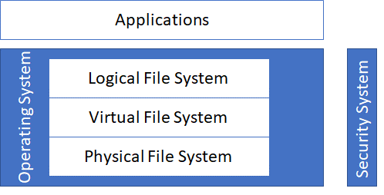

Logical File System provides only access that application is allowed (Least Privilege)

Virtual File System performs security checks against application’s security context when access is requested

Physical File System stores security information in metadata, e.g. owner and ACL

Security System holds users/groups and creates security context when user authenticates and applications starts

